TASK-3

Select and
Explain Three SSL Methods for the Dataset

East West University

April 10, 2026

Choice of SSL SSL1: SimCLR SSL2: DINOv2 SSL3: BYOL

SSL Method Key Mechanism Best For Rice Dataset Advantage
SimCLR Contrastive (Pos/Neg) Invariance Ignores camera angle/lighting variations BYOL Reconstructive (Masking) Texture Depth Learns the microscopic “fabric” of the grain DINOv2 Distillation (Teacher/Student) Shape/Semantics Automatically finds grain boundaries and edges

- Learns without labels
- Finds patterns automatically
- Great for image datasets

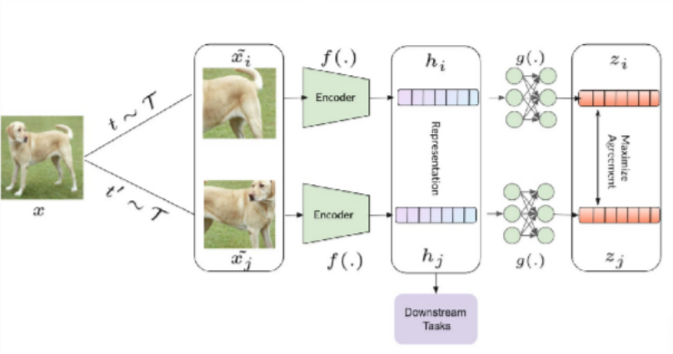

Figure 1: SimCLR Visualization

Key Idea: Learn representations by maximizing agreement between augmented views.

Pipeline:
- Input image → augment twice (x_{i} , x_{j} )
- Encoder f (·) (ResNet) → projection head g(·)
- Get embeddings z_{i} , z_{j}

Contrastive Loss (NT-Xent):

Numerical Example:

L_{i,j} = − log Σ
exp(sim(z_{i} , z_{j} )/τ ) exp(sim(z , z )/τ )
k̸=i i k

- sim(z_{i} , z_{j} ) = 0.8, others ≈ 0.2, τ = 0.5
- exp(1.6) = 4.95, others exp(0.4) = 1.49

Loss Calculation:

4.95 ≈ 0.74

Key Components:
- Strong augmentations
- Large batch size
L ≈ − log
4.95 + 3 × 1.49

- Projection head improves representation

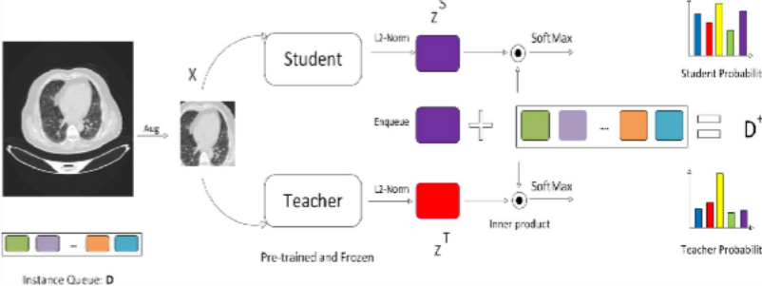

Figure 2: DINOv2 Visualization

Key Idea: Student-teacher self-distillation with centering + sharpening.

Architecture:
- Student network (learns)
- Teacher network (EMA of student)

Method:
- Multiple views (global + local crops)
- Teacher produces soft targets
- Student matches distributions

Loss (Cross-Entropy):

Numerical Example:
L = −
Σ
p_{t}(x) log p_{s}(x)

- Teacher: [0.7, 0.3], Student: [0.6, 0.4]

Loss Calculation:
−(0.7 log 0.6 + 0.3 log 0.4) ≈ 0.61

Key Components:
- Centering (avoid collapse)
- Sharpening (low entropy targets)
- No negative pairs needed

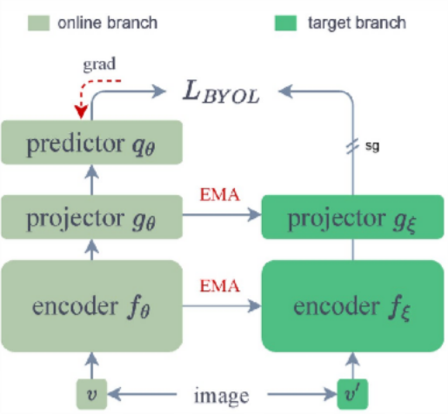

Figure 3: BYOL Visualization

Key Idea: No negative pairs; uses online and target networks.

Architecture:
- Online network: f_{θ}, projector, predictor
- Target network: f_{ξ} (EMA of θ)

Algorithm:
- Two views x, x′
- Online predicts target representation
- Update target via EMA

Loss Function:

Numerical Example:
- q_{θ} = [0.6, 0.8], z_{ξ} = [0.5, 0.7]

Loss Calculation:

2
L = q_{θ}(z_{θ}) − sg(z_{ξ}) 2

(0.6 − 0.5)² + (0.8 − 0.7)² = 0.01 + 0.01 = 0.02

Key Components:
- No contrastive loss
- Stop-gradient (sg)
- EMA target stabilizes training

